

FACULTY OF TECHNOLOGY AND ENGINEERING
DEVANG PATEL INSTITUTE OF ADVANCE TECHNOLOGY AND RESEARCH
DEPARTMENT OF INFORMATION TECHNOLOGY

A.Y. 2026-27 [SEMESTER 3]

LAB MANUAL

CEUE203: Object Oriented Programming


Practical 10

Thread pools and coordination
Problem Statement:
1. Thread-pool runner: execute ten tasks on a fixed pool and await completion.
2. Producer-consumer: coordinate a bounded buffer with wait and notify.
3. Deadlock: show opposite lock order and then finish transfers using a consistent order.

Solution:

DeadlockDemo.java
import java.util.concurrent.CountDownLatch;
public class DeadlockDemo {
private static final Object FIRST = new Object();
private static final Object SECOND = new Object();
private static final Object HASH_COLLISION_LOCK = new Object();
private static void unsafeTransfer(Object first, Object second, CountDownLatch ready) {
synchronized (first) {
ready.countDown();
try {
ready.await();
} catch (InterruptedException exception) {
Thread.currentThread().interrupt();
return;
}
synchronized (second) {
System.out.println("Unsafe transfer completed.");
}
}
}
private static void safeTransfer(Object first, Object second) {
int firstHash = System.identityHashCode(first);
int secondHash = System.identityHashCode(second);
if (firstHash == secondHash) {
synchronized (HASH_COLLISION_LOCK) {
lockAndTransfer(first, second);
}
} else if (firstHash < secondHash) {
lockAndTransfer(first, second);
} else {
lockAndTransfer(second, first);
}
}
private static void lockAndTransfer(Object first, Object second) {
synchronized (first) {
synchronized (second) {
System.out.println("Ordered transfer completed.");
}
}
}
public static void main(String[] args) throws InterruptedException {
CountDownLatch ready = new CountDownLatch(2);
Thread a = new Thread(() -> unsafeTransfer(FIRST, SECOND, ready), "unsafe-A");
Thread b = new Thread(() -> unsafeTransfer(SECOND, FIRST, ready), "unsafe-B");
a.setDaemon(true);
b.setDaemon(true);
a.start();
b.start();
Thread.sleep(200);
System.out.println("Opposite lock order deadlock observed: "
+ (a.isAlive() && b.isAlive()));
Object accountA = new Object();
Object accountB = new Object();
Thread safeA = new Thread(() -> safeTransfer(accountA, accountB));
Thread safeB = new Thread(() -> safeTransfer(accountB, accountA));
safeA.start();
safeB.start();
safeA.join();
safeB.join();
}
}

ProducerConsumerDemo.java
import java.util.ArrayDeque;
import java.util.Queue;
public class ProducerConsumerDemo {
private static final class Buffer {
private final Queue<Integer> values = new ArrayDeque<>();
private final int capacity;
Buffer(int capacity) { this.capacity = capacity; }
synchronized void put(int value) throws InterruptedException {
while (values.size() == capacity) wait();
values.add(value);
notifyAll();
}
synchronized int take() throws InterruptedException {
while (values.isEmpty()) wait();
int value = values.remove();
notifyAll();
return value;
}
}
public static void main(String[] args) throws InterruptedException {
Buffer buffer = new Buffer(2);
Thread producer = new Thread(() -> {
try {
for (int value = 1; value <= 8; value++) buffer.put(value);
buffer.put(-1);
} catch (InterruptedException exception) {
Thread.currentThread().interrupt();
}
}, "producer");
Thread consumer = new Thread(() -> {
try {
int value;
while ((value = buffer.take()) != -1) System.out.println("Consumed: " + value);
} catch (InterruptedException exception) {
Thread.currentThread().interrupt();
}
}, "consumer");
producer.start();
consumer.start();
producer.join();
consumer.join();
}
}

ThreadPoolRunner.java
import java.util.concurrent.ExecutorService;
import java.util.concurrent.Executors;
import java.util.concurrent.TimeUnit;
public class ThreadPoolRunner {
public static void main(String[] args) throws InterruptedException {
ExecutorService pool = Executors.newFixedThreadPool(3);
for (int task = 1; task <= 10; task++) {
int id = task;
pool.submit(() -> {
System.out.println("Task " + id + " on " + Thread.currentThread().getName());
try {
Thread.sleep(100);
} catch (InterruptedException exception) {
Thread.currentThread().interrupt();
}
});
}
pool.shutdown();
if (!pool.awaitTermination(5, TimeUnit.SECONDS)) {
pool.shutdownNow();
throw new IllegalStateException("Tasks did not finish before timeout.");
}
}
}

MiniBank Project Work:

MiniBank progress ? Practical 10
Completed: TransactionProcessor runs tasks on a fixed four-thread pool and waits for shutdown. Transfers consistently lock accounts in account-number order to avoid opposite-order deadlock.
Single project location: Java Programs\Minibank

Progressive source excerpts:

Minibank/src/main/java/minibank/service/TransactionProcessor.java
package minibank.service;
import java.time.Duration;
import java.util.Objects;
import java.util.concurrent.ExecutorService;
import java.util.concurrent.Executors;
import java.util.concurrent.TimeUnit;
public final class TransactionProcessor implements AutoCloseable {
private final ExecutorService executor = Executors.newFixedThreadPool(4);
public void submit(Runnable task) {
executor.execute(Objects.requireNonNull(task));
}
public void stop() {
executor.shutdown();
try {
if (!executor.awaitTermination(Duration.ofSeconds(30).toMillis(), TimeUnit.MILLISECONDS)) {
executor.shutdownNow();
if (!executor.awaitTermination(5, TimeUnit.SECONDS)) {
throw new IllegalStateException("Transaction tasks did not terminate.");
}
}
} catch (InterruptedException exception) {
executor.shutdownNow();
Thread.currentThread().interrupt();
throw new IllegalStateException("Interrupted while stopping transaction processor.",
exception);
}
}
@Override public void close() { stop(); }
}

Minibank/src/main/java/minibank/service/BankService.java ? ordered transfer locks
public void transfer(String fromNumber, String toNumber, long amount)
throws BankException, IOException {
Account from = find(fromNumber);
Account to = find(toNumber);
if (from.equals(to)) throw new IllegalArgumentException("Transfer accounts must differ.");
Account first = Comparator.comparing(Account::getAccountNumber).compare(from, to) < 0
? from : to;
Account second = first == from ? to : from;
synchronized (first) {
synchronized (second) {
from.withdraw(amount);
try {
to.deposit(amount);
} catch (InvalidAmountException | ArithmeticException exception) {
from.deposit(amount);
throw exception;
}
}
}
TransactionLog.append(logFile, "WITHDRAW " + amount);
TransactionLog.append(logFile, "DEPOSIT " + amount);
}

Output Screenshot:
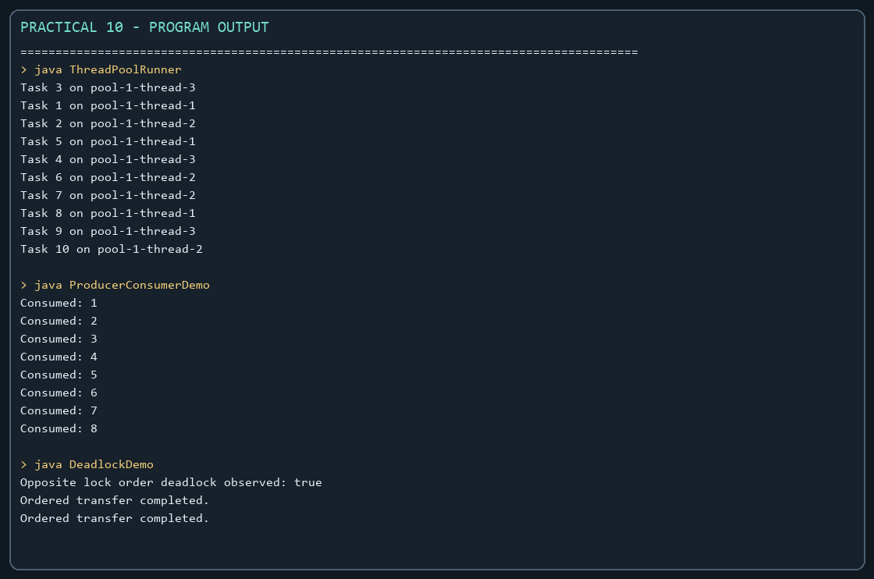
Captured from the compiled practical programs.

